**Step 1: Connect to Azure Cloud Shell**

1. Go to the [Azure Portal](https://portal.azure.com).

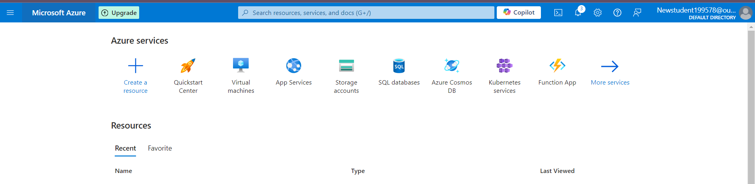

1. Click on the **Cloud Shell** icon (a terminal icon) at the top-right corner of the portal.

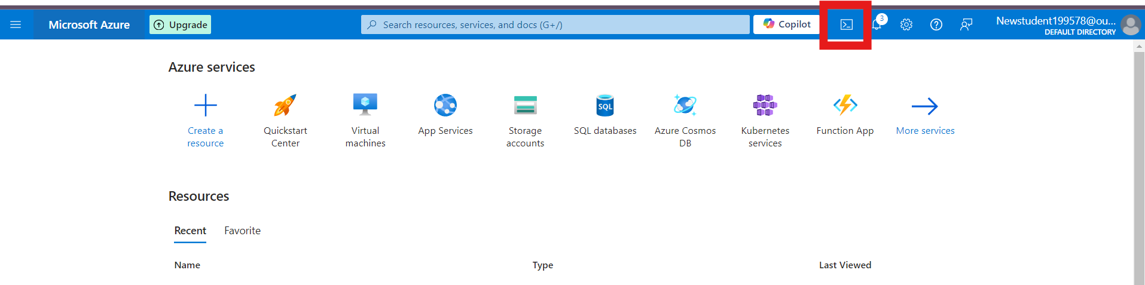

1. Select **PowerShell**.



1. The Cloud Shell will automatically connect to your Azure environment.

**Step 2: Create a Resource Group**

Once inside Cloud Shell:

**PowerShell:**

1. Run the following command to create the resource group:

**New-AzResourceGroup -Name "rg-1" -Location "South Central US"**

**1. Create 3 Storage Account**

**az storage account create --name shahidteam1 --resource-group rg-1 --location "South Central US" --sku Standard_LRS**

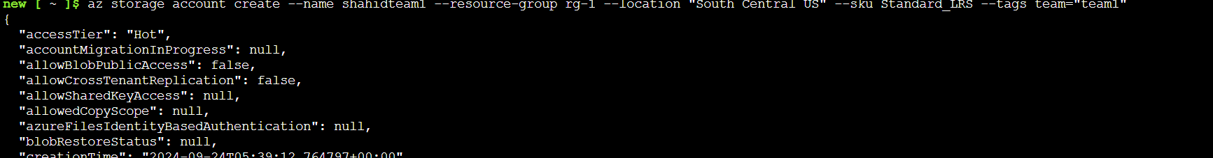

**2. Connect Azure Storage Explorer to This Storage Account**

**Steps:**

1. Download and install **Azure Storage Explorer** from the official website if you don't have it already.
   * Link: [Azure Storage Explorer](https://azure.microsoft.com/en-us/features/storage-explorer/)
2. Open **Azure Storage Explorer**.
3. Click on **"Add an Account"** in the left panel.
4. Select **"Azure"**
5. Sign in with your Azure credentials.
6. Once signed in, you should see all the storage accounts under your subscription.
7. Locate your newly created storage account (**shahidteam1**) and expand it to explore the containers, blobs, files, and other storage services.

